Experiment No.04
Title: Measurement of signal strength vs. distance for Wi-Fi router.

Aim: To measure and analyze the variation of Wi-Fi signal strength (RSSI) with increasing distance from a Wi-Fi router and understand the effect of path loss in wireless communication.
Requirement:

Hardware
- Wi-Fi Router
- Laptop with Wi-Fi adapter
- Measuring tape (10–20 m)
Software
- Python 3.x
- Jupyter Notebook / Google Colab / VS Code
- Libraries:
  - matplotlib
  - numpy
Theory :

Wi-Fi Signal Strength
Wi-Fi devices communicate using radio waves in the 2.4 GHz or 5 GHz frequency bands. The strength of the received signal is measured using the Received Signal Strength Indicator (RSSI).
RSSI is expressed in dBm (decibel-milliwatts).
Typical RSSI values are:
RSSI (dBm) | Signal Quality
-30 | Excellent
-50 | Very Good
-60 | Good
-70 | Fair
-80 | Weak
-90 | Very Poor
A value closer to 0 dBm indicates a stronger signal.
As the distance between the Wi-Fi router and receiver increases, the signal strength decreases due to:
- Free-space path loss
- Walls and obstacles
- Reflection

Relationship Between Distance and Signal Strength
The received signal decreases approximately according to the logarithmic path loss model:
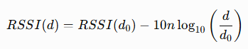
Where:
- RSSI(d) = Signal strength at distance d
- RSSI(d₀) = Signal strength at reference distance
- n = Path loss exponent (typically 2–4)
- d = Distance from router
- d₀ = Reference distance (usually 1 m)

Procedure
- Switch on the Wi-Fi router.
- Connect the laptop to the router.
- Place the laptop at 1 meter from the router.
- Record the RSSI value.
- Move the laptop to 2 m, 4 m, 6 m, 8 m, and 10 m.
- Record RSSI at each distance.
- Enter the readings into the Python program.
- Plot Signal Strength versus Distance.
- Analyze the graph.
Observation Table (Sample)
Distance (m) | RSSI (dBm)
1 | -35
2 | -42
4 | -50
6 | -57
8 | -63
10 | -68

Python Code
# Distance from Wi-Fi router (meters)
distance = [1, 2, 4, 6, 8, 10]

# Sample RSSI values (dBm)
rssi = [-35, -42, -50, -57, -63, -68]

plt.figure(figsize=(8, 5))

plt.plot(
distance,
rssi,
marker='o',
linewidth=2
)

plt.title("Wi-Fi Signal Strength vs Distance")
plt.xlabel("Distance from Router (m)")
plt.ylabel("Signal Strength (RSSI in dBm)")

plt.grid(True)

# Set y-axis from higher negative values to lower negative values
# Top → -30 dBm (stronger)
# Bottom → -70 dBm (weaker)
plt.ylim(-70, -30)

plt.show()

Expected Output
The graph should show that the Wi-Fi signal strength decreases (becomes more negative) as the distance from the router increases.

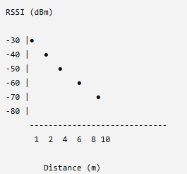

Observation
- RSSI decreases as the distance from the router increases.
- Signal attenuation follows a logarithmic trend.
- Obstacles such as walls or furniture further reduce the signal strength.
- The strongest signal is observed nearest to the router.

Output

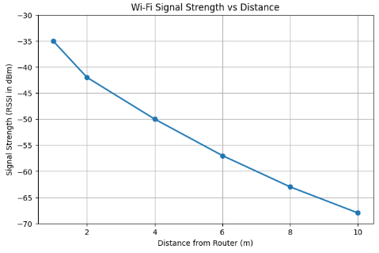

Applications
- Wi-Fi network planning
- Home and office wireless optimization
- Access Point placement
- Wireless coverage analysis
- Smart buildings
- IoT device deployment
- Campus network design
- Industrial wireless monitoring
- Mobile communication systems
Conclusion:
The experiment successfully demonstrated that the Wi-Fi signal strength decreases with increasing distance from the router due to wireless path loss. The plotted graph clearly illustrates the inverse relationship between distance and received signal strength (RSSI), validating the basic principles of wireless communication.

